**EXERCISE NO: 14**

**DATE: 22/11/2020**

**AIM:**

 To find validity of a string of parentheses, '(', ')', '{', '}', '[' and '].

**PROGRAM:**

def areBracketsBalanced(expr):

stack = []

for char in expr:

if char in ["(","{","["]:

stack.append(char)

else:

if not stack:

return False

current_char = stack.pop()

if current_char == '(':

if char != ")":

return False

if current_char == '{':

if char != '}':

return False

if current_char == '[':

if char != "]":

return False

if stack:

return False

return True

if __name__ == "__main__":

expr = "{()}[]"

if areBracketsBalanced(expr):

print("valid")

else:

print("invalid")

**OUTPUT:**

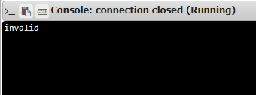

**LINK:** [**http://103.53.53.18/mod/vpl/forms/edit.php?id=327&userid=1695**](http://103.53.53.18/mod/vpl/forms/edit.php?id=327&userid=1695)

**RESULT:**

Thus the validity of the strings of parantheses are checked and displayed.